**7.** **SQUARE WAVE GENERATOR USING OPERATIONAL AMPLIFIER**

**7.1 OBJECTIVE**

Design a square wave generator using operational amplifier.

**7.2 HARDWARE REQUIRED**

|  |  |  |  |
| --- | --- | --- | --- |
| **S.No** | **Equipment/Component name** | **Specifications/Value** | **Quantity** |
| 1 | IC 741 | Refer data sheet in appendix | 1 |
| 2 | Cathode Ray Oscilloscope | (0 – 20MHz) 1 | 1 |
| 3 | Resistors | 10k  8.2k | 2  1 |
| 5 | Capacitors | 0.1µf | 1 |

**7.3 Square wave generator**

The square wave generator circuit is forced to operate in the saturated region. That is, the o/p of the Op-Amp is forced to swing between positive saturation (+Vsat) and negative saturation (-Vsat), resulting in the square wave output. This square wave generator is also called free running or astable multivibrator.

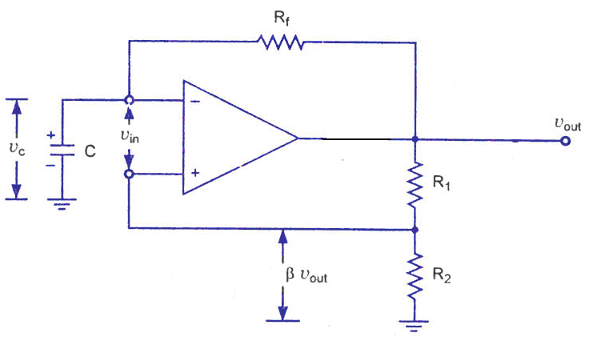

R2/[R1+R2]Vout = βVout

Rf=10k R1=10k R2=8.2k C=0.1µf

A fraction of the output (βV◦) is feedback to the input non-inverting terminal. Thus the Vref is βV◦ and may take values as + βVsat or – βVsat. The output is also feedback to the negative i/p terminal after integrating by means of a low pass RC combination. Whenever the i/p at the negative terminal exceeds Vref switching takes place resulting in a square wave output. Time period of square wave is given as

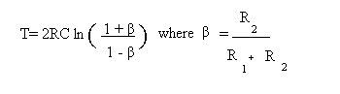

for R1 = 1.16 R2, it can be seen that T = 2RC.

T = 1.6 ms

V◦ = 24 V

Vsat = 12V; βVsat = 4v

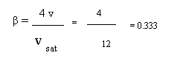

|  |  |  |  |
| --- | --- | --- | --- |
| **Theoretical O/P** | | **Practical O/P** | |
| TOTAL TIME |  | TOTAL TIME |  |
| TON |  | TON |  |
| TOFF |  | TOFF |  |
| AMPLITUDE of  Square wave | Close to VCC | AMPLITUDE of  Square wave |  |
| Charg& Discharging  Of Capcitor by measuring Amplitude | βVsat | Charg& Discharging  Of Capcitor by measuring Amplitude |  |

**7.4 PROCEDURE:**

1. Connect the circuit as shown in the figure with the designed values.
2. Switch on the power supply and observe the waveform.
3. Note down the amplitude and time period.
4. Plot the waveforms on a graph sheet.
   1. **PRE-LAB**
5. Where do you use IC oscillators?
6. Explain the operation of square wave generator with respect to voltage across capacitor and output waveform.
7. Why zener diode is used at the output terminal of square generator?
8. To reduce both output and capacitor voltage swing
9. To reduce output voltage swing
10. To reduce input voltage swing
11. To reduce capacitor voltage swing
12. What could be the possible output waveform for a free running multivibrator whose op-amp has a supply voltage of ±5V operating at 5KHz?
    1. **POST-LAB**
13. Explain the main difference between an amplifier and an oscillator.
14. Calculate the frequency of oscillation of square wave generator if R2=10kΩ, R1=11.kΩ, Rf=100kΩ, C=0.01μf.
15. Given that the feedback factor is 0.6, find the time period of the square wave generator with R=10KΩ and C=1µF.
16. A square wave oscillator has fo = 1KHz. Assume the resistor value to be 10KΩ and find the capacitor value?

**RESULT:**